Diffraction of Sound
Diffraction: the bending of waves around small* obstacles and the spreading out of waves beyond small* openings.
* small compared to the wavelength
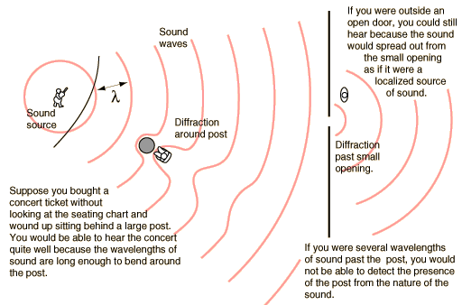
Important parts of our experience with sound involve diffraction. The fact that you can hear sounds around corners and around barriers involves both diffraction and reflection of sound. Diffraction in such cases helps the sound to "bend around" the obstacles. The fact that diffraction is more pronounced with longer wavelengths implies that you can hear low frequencies around obstacles better than high frequencies, as illustrated by the example of a marching band on the street. Another common example of diffraction is the contrast in sound from a close lightning strike and a distant one. The thunder from a close bolt of lightning will be experienced as a sharp crack, indicating the presence of a lot of high frequency sound. The thunder from a distant strike will be experienced as a low rumble since it is the long wavelengths that can bend around obstacles to get to you. There are other factors such as the higher air absorption of high frequencies involved, but diffraction plays a part in the experience.
You may perceive diffraction to have a dual nature, since the same phenomenon that causes waves to bend around obstacles causes them to spread out past small openings. This aspect of diffraction also has many implications. Besides being able to hear the sound when you are outside the door as in the illustration above, this spreading out of sound waves has consequences when you are trying to soundproof a room. Good soundproofing requires that a room be well sealed, because any openings will allow sound from the outside to spread out in the room - it is surprising how much sound can get in through a small opening. Good sealing of loudspeaker cabinets is required for similar reasons.
Another implication of diffraction is the fact that a wave that is much longer than the size of an obstacle, like the post in the auditorium above, cannot give you information about that obstacle. A fundamental principle of imaging is that you cannot see an object that is smaller than the wavelength of the wave with which you view it. You cannot see a virus with a light microscope because the virus is smaller than the wavelength of visible light. The reason for that limitation can be visualized with the auditorium example: the sound waves bend in and reconstruct the wavefront past the post. When you are several sound wavelengths past the post, nothing about the wave gives you information about the post. So your experience with sound can give you insights into the limitations of all kinds of imaging processes.

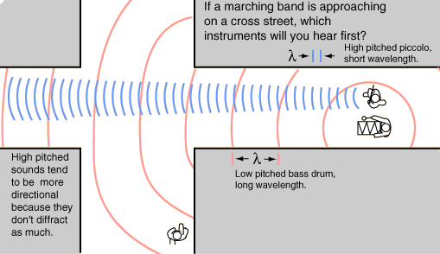
The long wavelength sounds of the bass drum will diffract around the corner more efficiently than the more directional, short wavelength sounds of the higher pitched instruments

Advanced use of diffraction.

Loudspeaker Sound Contours
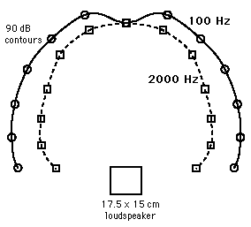 | One consequence of diffraction is that sound from a loudspeaker will spread out rather than just going straight ahead. Since the bass frequencies have longer wavelengths compared to the size of the loudspeaker, they will spread out more than the high frequencies. The curves at left represent equal intensity contours at 90 decibels for sound produced by a small enclosed loudspeaker. It is evident that the high frequency sound spreads out less than the low frequency sound.  These equal intensity curves were measured in an undergraduate sound laboratory experiment.
Note that the wavelength of the 100 Hz sound is about 3.45 meters, much larger than the speaker, while that of the 2000 Hz sound is about 18 cm, about the size of the speaker.
The realities of diffraction may affect your choice of loudspeakers for your personal listening. Very small loudspeakers are often promoted as having sound just as good as a large loudspeaker. There is reason to be sceptical about such claims on physical grounds. Large speakers are inherently more efficient in producing bass frequencies into a room just because their size compares more favourably with the wavelengths of those sounds. Even if that basic problem is overcome by electronic equalization of the sound input to the speakers and the design of the crossover networks which provide the signal to the different components of the loudspeaker, there is no escaping the implications of diffraction. Small loudspeakers will spread the bass frequencies considerably more than the high frequencies. This difference between the equal-loudness patterns of highs and lows becomes more and more pronounced as you produce smaller and smaller speakers. So you might conceivably get equivalent sound directly on-axis with the speaker, but as you move away from the axis, the high frequencies will drop off more rapidly than the lows. Practically, this limits the audience region for optimal listening. It might be fairly said that if the speakers are just for you, you might be satisfied with the small speakers because you can position yourself at the ideal-listener location. But if you have guests, they will not be as satisfied because of the greater off-axis variations from the small speakers.

Web sites.

Calculation of speed of sound applet:
http://hyperphysics.phy-astr.gsu.edu/hbase/sound/souspe.html#c1

Lots more on wave properties:
http://www.glenbrook.k12.il.us/gbssci/phys/Class/sound/soundtoc.html

